a data structure is a way of organizing data so they can be used efficiently.
Why are they important.
- they are essential ingredients in creating fast and powerful algorithms.
- they help us manage and organize our data in a very natural way.
- it makes code cleaner and easier to understand
What is an abstracted type And how does it differ from a deep structure.
an abstracted type is an abstraction of a data structure which provides only the interface to which that data structure must adhere to.
The interface does not give any specific details on how a specific dish should be implemented or in what programming language.
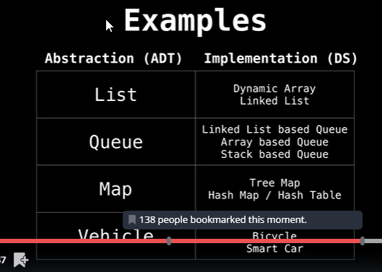
Time Space complexity
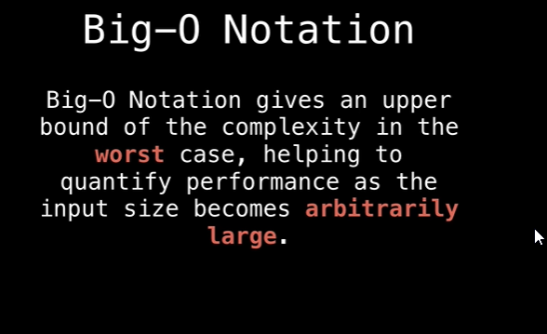
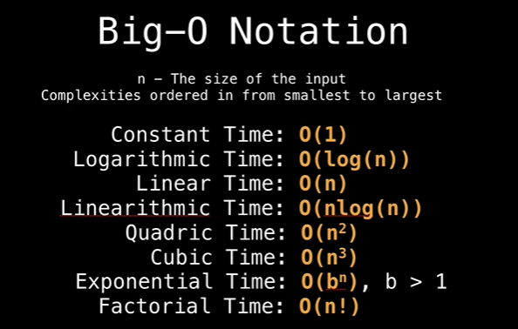
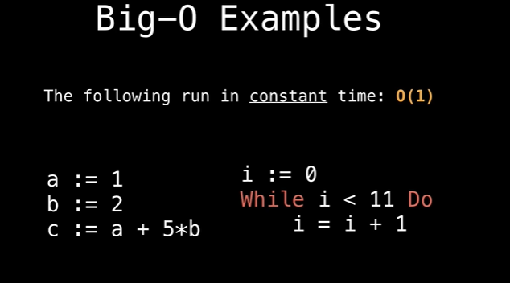
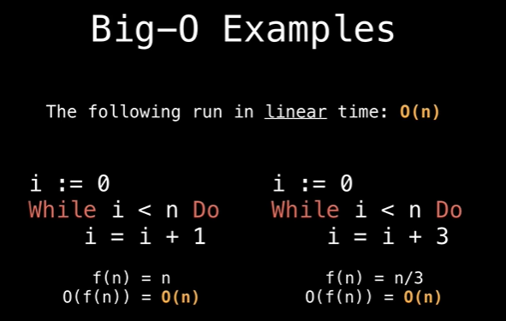
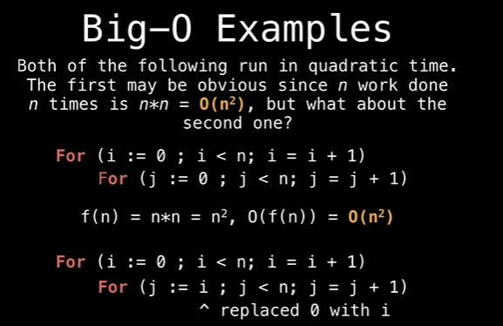
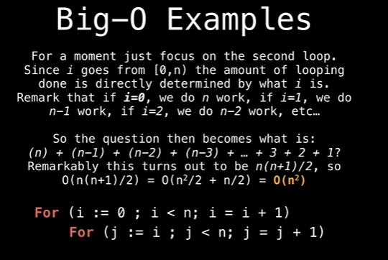
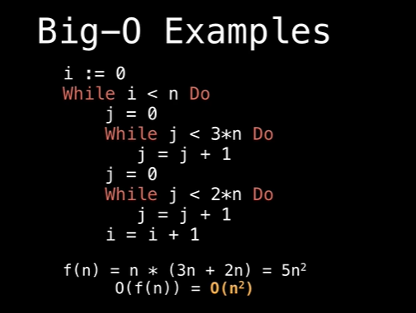
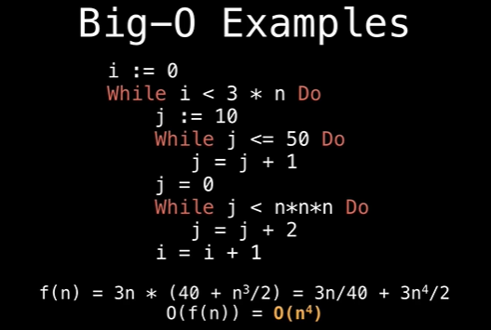
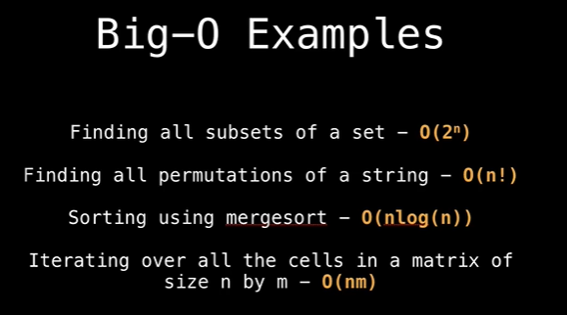
Static and Dynamic Arrays:
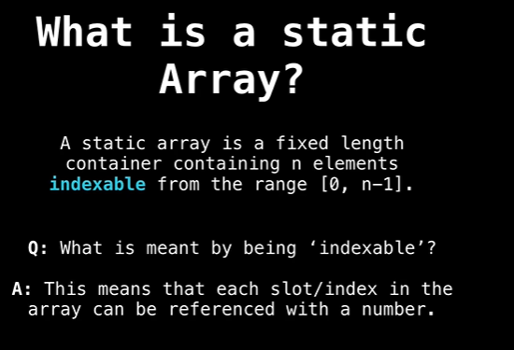
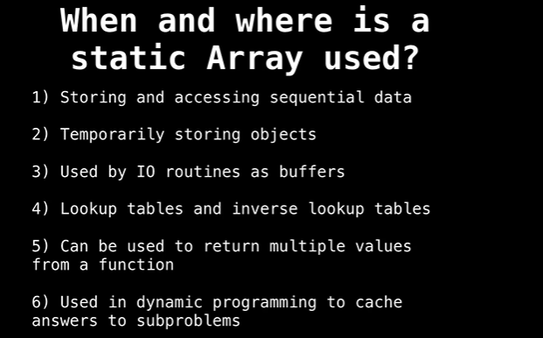
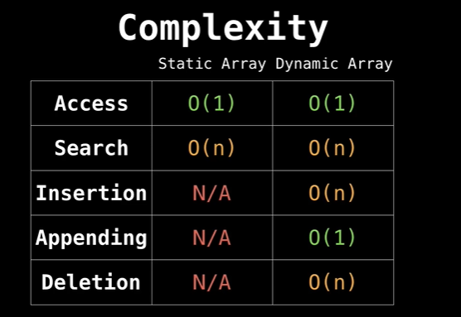
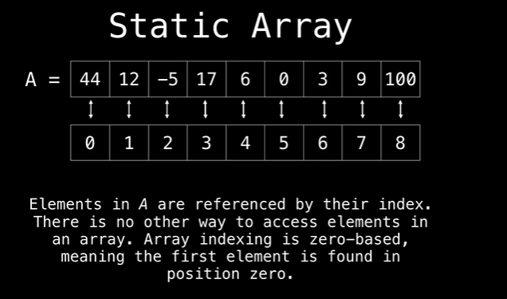
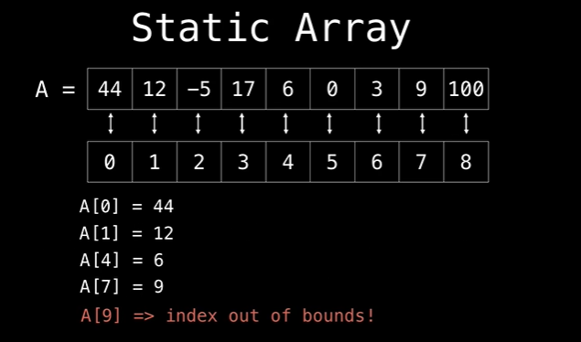
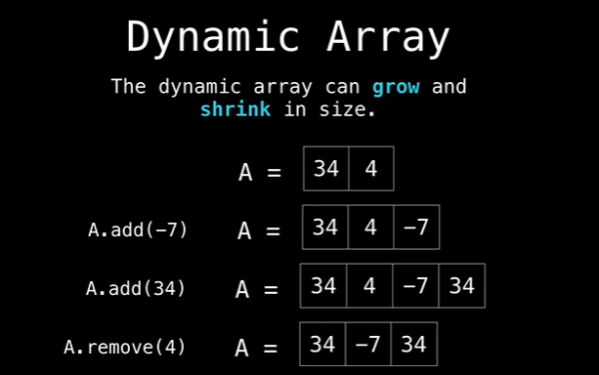
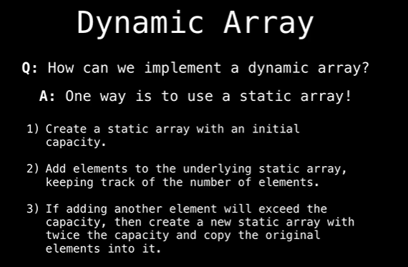
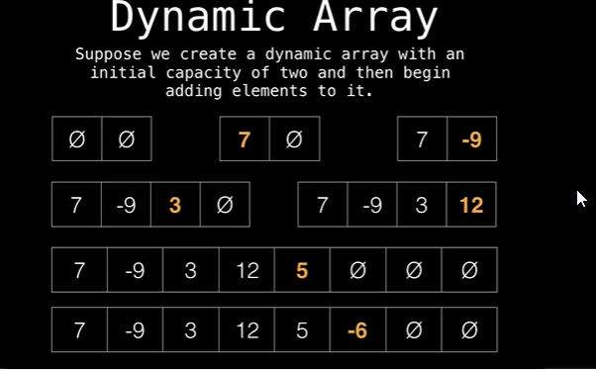
Why is it important that we grow the size of the dynamic array exponentially when resizing?
To keep the time complexity of insertions O(1). If we grow our array at an exponential rate the cost of inserting as well as resizing becomes negligible.

